HUB4049 DEEPL LEARNING FOR MEDICAL IMAGE CLASSIFICATION


Prepared by: Tadala Mitumbili

Due: 25 may 2026

Introduction
For this report we will be analysing the binary classification of a chest X-ray image in order to investigate the presence of pneumonia. X-ray imaging relies on the use of differential attenuation of photons through tissues, when dealing with pneumonia it generates fluid in the alveolar spaces which then transforms the expected density and attenuation profiles. Examination of these images is crucial for for early and accurate diagnosis for patients. Through the introduction of AI convolutional Neural Networks (CNN’s) there can now be a reduced workload for clinicians as well as serving a as secondary diagnostic confirmation. By flagging high probability patients in real time, the AI can prioritise the most critical patients.

Datasets description and preprocessing
Primary data source for this project is from PneumoniaMNIST. Which a subset of a larger paediatric chest X-ray database.

Dataset characteristics
The dataset is made up of total of 5 865 images. Which are all standardised to a low resolution of 28x28. Images are grouped in to three independent subsets to ensure robust model evaluation. These groups are
- Training set which has 4708 images
- Validation set which has 524 image s
- Test set which has 624 images
Through analysis of the training set we are able to uncover a large class imbalance. The training data is made up of 72.4 % pneumonia cases which about 3494 and about 1214 normal cases or 25.8%. This imbalance will have an effect in terms of classification.
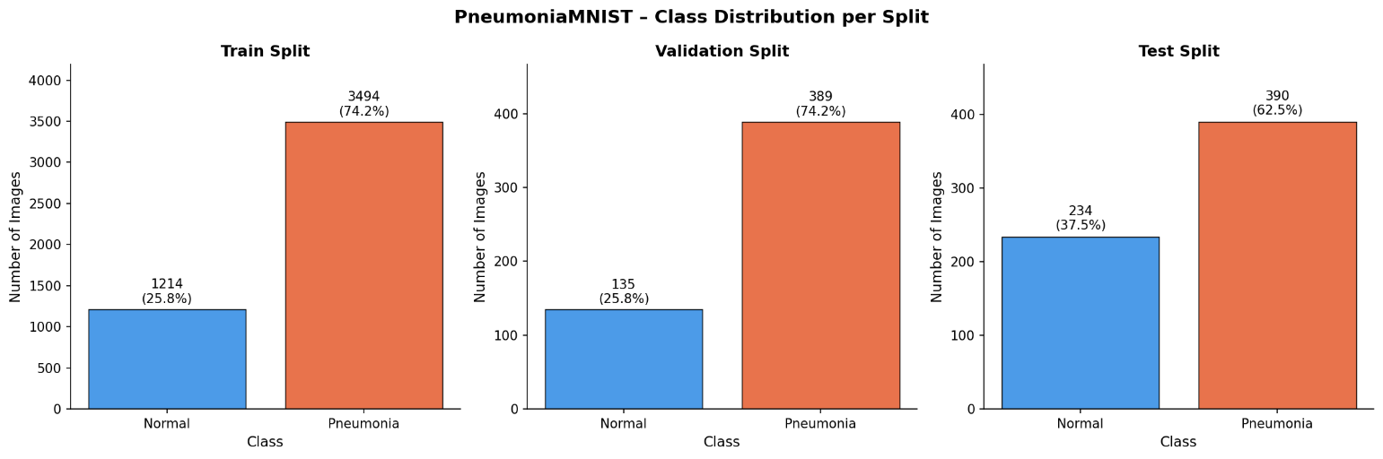
Figure 1 pneumonia class distribution for each split
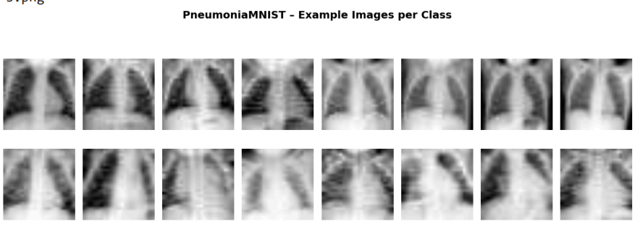
Figure 2 examples image per class
Without proper regularisations an untrained neural network may achieve an abnormally high level of accuracy by simply predicting the majority class.

Preprocessing and augmentation pipeline
For sake of stability in the training process we convert raw integer intensities to floating point tensors and normalised. The global training set mean which was 0.5719 and the st dev of 0.1684 which was subtracted form all images. This helped to ensure that the inputs have a mean near zero and a unit variance. This is essential when it come to stopping larger weight gradients from impairing the network.
To avoid overfitting on the limited 4708 training images, a strict medically justified data augmentation pipeline is used for the training set. This consists of:
- A horizontal flip (p=0.5) mimicking the natural variation for a patients positioning without altering the underlying pathology
- Random rotation of max 10 degree this can account for the minor tilt form patients during the scan. Which is extremely common in clinical patients. But care needs to be taken to avoid extreme rotation.
- Colour jitters to simulate variations in brightness and contrast from different exposure levels, detector calibrations and varying tissue depths.
If wanted to adapt this database for a more realistic resolution dataset certain fundamental changes would be needed. We would need pytorch dataset classes that can handle png or dicom files of varied resolutions and ratios would also need a more method of dynamic padding to make square aspect ratios before downscaling to standard resolutions. Additionally extreme imbalances would then require algorithmic oversampling or weighted loss functions. Where misclassifying the minority class will hold a heavier penalty.

Model implementation
In order to have a defined baseline for performance a convolutional architecture was made and compared against pretrained resnet18 model.

Simple CNN Architecture
A custom-made CNN was designed as a sequential feature extractor and classifier. Containing a total of 105,473 trainable parameters. The architecture is mad of three convolutional layers with each layer making us of a 3x3 kernel with a padding of 1 to conserve the spatial dimensions before down sampling. The channel depth increases sequentially form the 1 channel grayscale input to 16,32 and 64 maps. After each convolution layer a rectified linear unit (RLU) activation function introduces noon linearity , and a 2x2 max pooling layer halves the spatial dimensions. the initial 28x28 image is systematically reduced to a highly abstract 3x3 grid containing 64 dense feature channels. his data is flattened into a 576-element 1D tensor and passed through three fully connected linear layers (128, 64, and 1 neuron, respectively). A Sigmoid activation on the final output neuron maps the raw logits into a probabilistic range between 0.0 and 1.0.

Training Strategy and Regularisation
We optimized the model using the Adam algorithm with a standard learning rate of 0.001. Binary cross entropy (BCE Loss) was selected as the loss function, and is appropriate in evaluating the probability output of a binary classifier. The model was trained with a batch size of 32 for a maximum of 50 epochs. Multiple regularisation strategies were leveraged to fight the tendency of the model to over fit the imbalanced data.
- Dropout: A dropout layer with a probability of 0.5 was inserted before the first fully connected layer, randomly severing neural connections during training to force the network to learn redundant, robust feature representations.
- Learning Rate Scheduling: A ReduceLROnPlateau scheduler was utilised to halve the learning rate if the validation loss stagnated for 5 epochs, allowing for finer weight adjustments in the later stages of training.
- Early Stopping: To prevent the model from memorising the training data, training was strictly monitored. If validation loss failed to improve by a minimum delta of 0.001 for 10 consecutive epochs, training was halted.

Training curve analysis
Looking at the generated curves we can determine the success of the learning.
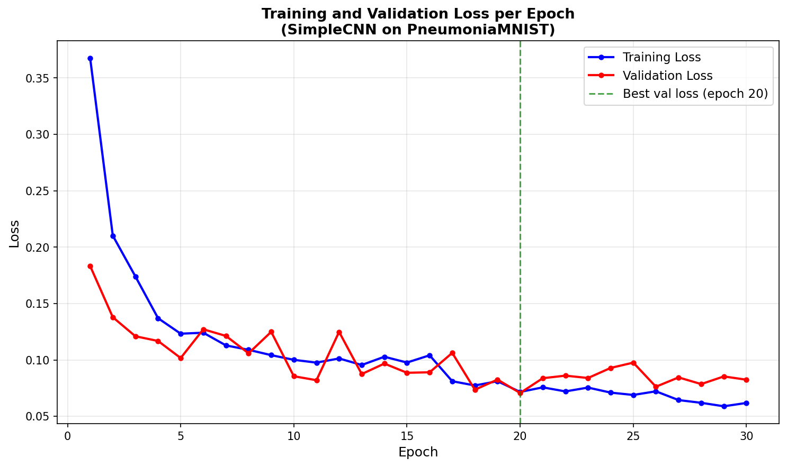
Figure 3 Training curves for CNN

We can notice the training loss decreased steadily from around 0.367 to 0.062. The validation tracked this descent eventually reaching its absolute minimum of 0.071 at epoch 20. We can see this tracking in the code. we see the validation loss begun to oscillate and slowly rise reaching 0.0824 by epoch 30 , indicating the onset of overfitting. The early stopping protocol correctly intervened. Terminating the training loop at epoch 30 and ensuring the most generalised weight from epoch 20 were retained.

ResNet18 adaptation
IN terms of a comparison a ResNet18 model , pretrained on the ImageNet database was adapted for this task. The foundational advantages of resnet are its residual skip connections which allow for more in depth networks without the cost of vanishing gradients . In order for the medical image to be processed the initial convolutional layer is modified to accept 1 channel grayscale input rather than 3 channel RGB images. The fully connected final layer was stripped and replaced with single binary output node. the more in-depth extraction layers were frozen to allow for only the final classification layers to be fine tuned to the X-ray data, this significantly reduces computational overhead.

Results

4.2. Results
We evaluated the performance of the models p nth isolated 624image test dataset. The custom Simple CNN yielded extremely high decisive results, which were quite weighted toward disease detection.
MODEL PERFORMANCE ON TEST SET
Accuracy | 0.8654
Sensitivity | 0.9974
Specificity | 0.6453
Precision | 0.8242
F1 Score | 0.9026
AUC score | 0.9586
Figure 4 performance on test set

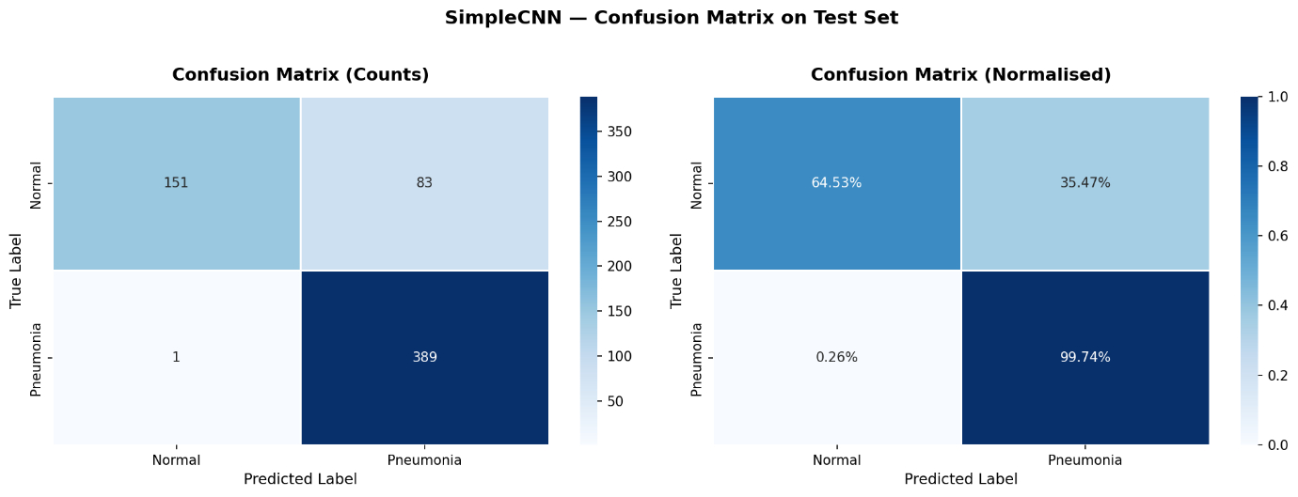
Figure 5 confusion matric on test set
Simple CNN Confusion Matrix Breakdown:
- True Positives (TP): 389 (Pneumonia correctly detected)
- True Negatives (TN): 151 (Normal correctly identified)
- False Positives (FP): 83 (Normal wrongly flagged as Pneumonia)
- False Negatives (FN): 1 (Pneumonia missed)

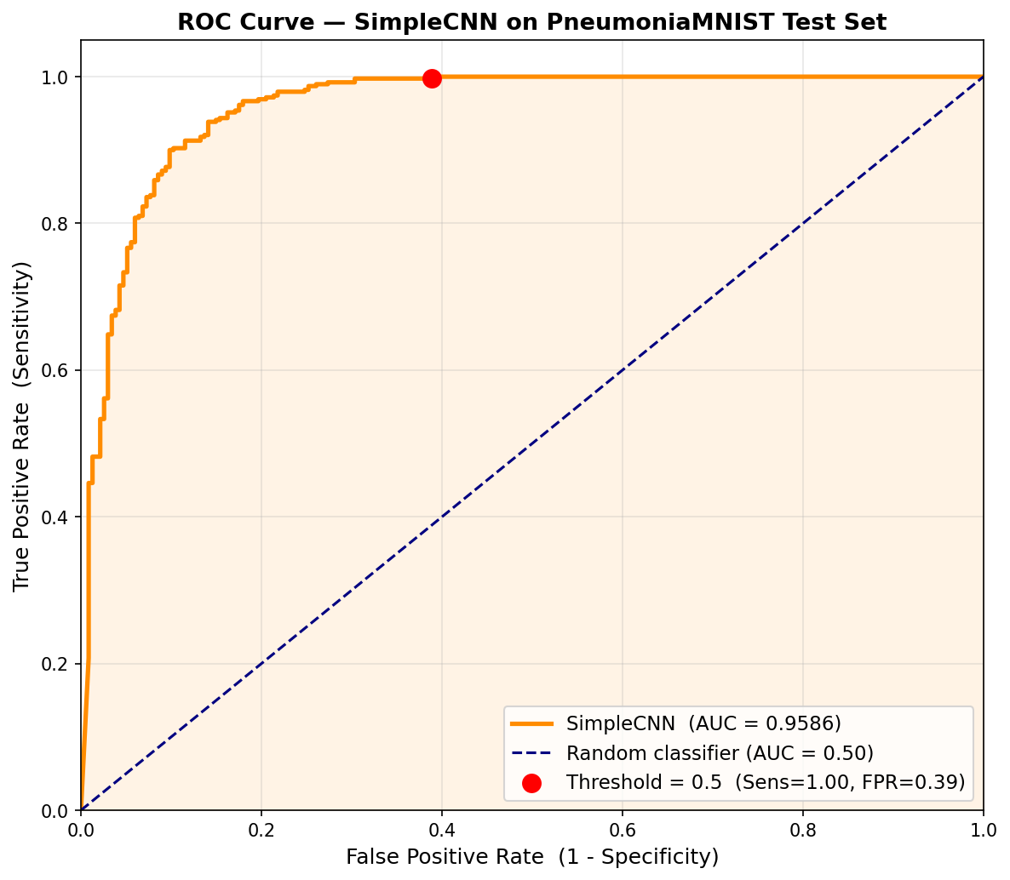
Figure 6 ROC curve
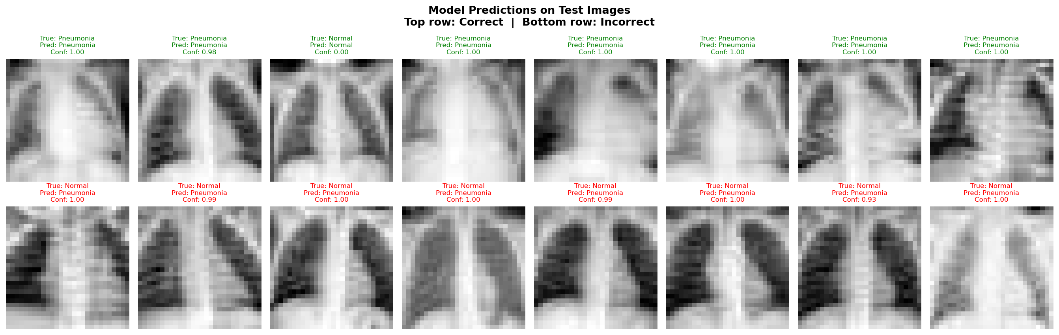

4.2. Results Analysis
The Simple CNN demonstrates exceptional capability in identifying disease, with a Sensitivity of 99.74%. Out of the 390 actual pneumonia cases in the test set, the model missed only a few images with only 1 False Negative. The ROC curve confirms this robust performance, the curve sits close to the top-left corner, resulting in an excellent Area Under the Curve (AUC) of 0.9586. This is a massive improvement over the 0.50 score you would get from random guessing.
However, this hyper-sensitivity comes at the direct cost of Specificity, which sits at a comparatively low 64.53%. The model aggressively predicts pneumonia, resulting in 83 False Positives (normal lungs flagged as diseased). This behaviour is a direct mathematical consequence of the 74.2% pneumonia class imbalance present in the training data; the model has learned that predicting disease is statistically safer.
The predictions were as follows

Figure 7 predictions grid on test images

Discussion
While the Simple CNN achieved a score (0.9026) and near-perfect sensitivity, the model possesses several engineering and clinical limitations.

Limitations and Bias
The primary limitation is the input resolution. Down sampling complex physiological structures to 28x28 pixels significantly reduces the subtle textural features, such as the minor opacities, which are crucial for diagnosing early-stage or atypical pneumonia. Furthermore, the model is highly susceptible to dataset bias. Because it was trained on an imbalanced dataset, it exhibits a strong positive prediction bias evidenced by the 83 false positives. If the original demographic data consisted entirely of paediatric patients as is common with standard open-source pneumonia sets, the model's performance would likely degrade sharply if applied to geriatric chest X-rays, representing a critical failure in out-of-distribution generalisation.

Clinical Deployment
In its current state, this model cannot be deployed autonomously in a clinical setting. While its 99.74% sensitivity is highly desirable for a medical triage tool—because a False Positive which could mean sending a healthy patient for a secondary review is infinitely preferable to a False Negative which would mean sending a sick patient home —the 64.5% specificity means it would generate too many false alarm. Which would be far from ideal

Future Improvements
To improve the model for clinical viability, several steps must be taken. First, training must occur on high-resolution data (e.g., 512x512) to preserve anatomical fidelity. Second, the loss function should be updated to a weighted Binary Cross-Entropy to mathematically penalise false positives and force the network to respect the minority "Normal" class. Finally, unfreezing additional blocks in the ResNet18 architecture and utilizing a lower learning rate could allow the network to learn deeper, more specific lung pathology features rather than relying on the broad, generic edge-detection filters imported from ImageNet.

AI Clause
AI was used to identify the reasons behind small bugs in the code such as syntax or logic errors. It was used to initially gain quick insight on pytorch and CNN training related concepts and code which was validate through the pytorch training portal.

